Earth Ocean

***What is the Relation of Earth and the Ocean?***

The Story of ocean is the story of life. Ocean define our planet that covers the majority area of our planet Earth. Driving water cycle dominates our land and surrounding atmosphere. Moreover, the story of oceans have close relationship with our home Earth that reaches deep into the universe and places us in rich family of ocean world.

***What do we mean by Ocean? How much area do Ocean covers in Earth?***

An ocean (from Ancient Greek Ὠκεανός, transc. Okeanós) is a body of water that composes much of a planet's hydrosphere (1). The ocean covering approximately 71% of Earth's surface and 90% of the Earth's biosphere. The ocean contains 97% of Earth's water, and oceanographers have stated that less than 5% of the World Ocean has been explored. The total volume is approximately 1.35 billion cubic kilometers (320 million cu mi) with an average depth of nearly 3,700 meters (12,100 ft)(2). The world ocean is the principal component of Earth's hydrosphere, it is integral to life, forms part of the carbon cycle, and influences climate and weather patterns. The World Ocean is the habitat of 230,000 known species, but because much of it is unexplored, the number of species that exist in the ocean is much larger, possibly over two million. The origin of Earth's oceans is unknown; oceans are thought to have formed in the Hadean eon and may have been the cause for the emergence of life (3). More than two-thirds of the fresh water is locked up in ice-caps and glacier.

***Segmentation of Ocean covered in Earth ?***

Oceanographers divide the ocean into different vertical zones defined by physical and biological conditions. The pelagic zone includes all open ocean regions, and can be divided into further regions categorized by depth and light abundance. The photic zone includes the oceans from the surface to a depth of 200 m; it is the region where photosynthesis can occur and is, therefore, the most biodiverse. Because plants require photosynthesis, life found deeper than the photic zone must either rely on material sinking from above (see marine snow) or find another energy source. Hydrothermal vents are the primary source of energy in what is known as the aphotic zone (depths exceeding 200 m). The pelagic part of the photic zone is known as the epipelagic.

The pelagic part of the aphotic zone can be further divided into vertical regions according to temperature. The mesopelagic is the uppermost region. Its lowermost boundary is at a thermocline of 12 °C (54 °F), which, in the tropics generally lies at 700–1,000 meters (2,300–3,300 ft). Next is the bathypelagic lying between 10 and 4 °C (50 and 39 °F), typically between 700–1,000 meters (2,300–3,300 ft) and 2,000–4,000 meters (6,600–13,100 ft), lying along the top of the abyssal plain is the abyssopelagic, whose lower boundary lies at about 6,000 meters (20,000 ft). The last zone includes the deep oceanic trench, and is known as the hadalpelagic. This lies between 6,000–11,000 meters (20,000–36,000 ft) and is the deepest oceanic zone.

The benthic zones are aphotic and correspond to the three deepest zones of the deep-sea. The bathyal zone covers the continental slope down to about 4,000 meters (13,000 ft). The abyssal zone covers the abyssal plains between 4,000 and 6,000 m. lastly, the hadal zone corresponds to the hadalpelagic zone, which is found in oceanic trenches.

The pelagic zone can be further subdivided into two subregions: the neritic zone and the oceanic zone. The neritic zone encompasses the water mass directly above the continental shelves whereas the oceanic zone includes all the completely open water.

In contrast, the littoral zone covers the region between low and high tide and represents the transitional area between marine and terrestrial conditions. It is also known as the intertidal zone because it is the area where tide level affects the conditions of the region.

If a zone undergoes dramatic changes in temperature with depth, it contains a thermocline. The tropical thermocline is typically deeper than the thermocline at higher latitudes. Polar waters, which receive relatively little solar energy, are not stratified by temperature and generally lack a thermocline because surface water at polar latitudes are nearly as cold as water at greater depths. Below the thermocline, water is very cold, ranging from −1 °C to 3 °C. Because this deep and cold layer contains the bulk of ocean water, the average temperature of the world ocean is 3.9 °C.[citation needed] If a zone undergoes dramatic changes in salinity with depth, it contains a halocline. If a zone undergoes a strong, vertical chemistry gradient with depth, it contains a chemocline.

The halocline often coincides with the thermocline, and the combination produces a pronounced pycnocline(4).

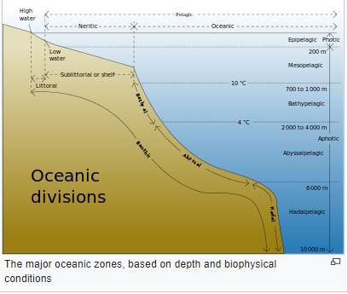

Fig: Different Segmentation of Ocean

***Origin of water in Earth?***

The origin of water are in the stars. Hydrogen was created in the big-bang and Oxygen origin from the core of stars. A vast amount of water source in gaseous form exist in the vast stellar nurseries of our Galaxy. The Hubble telescope orbiting around the helix Nebula founds existence of water molecule. Also gather information that Hydrogen and Oxygen combined together to form water in various processes in the ejected atmosphere of the dyeing star.

***Major Source of water in Earth?***

Water molecules are still in the orion Nebula and largely form water recent now. Interestingly, orion Nebula is so vast that it can produce a large amount of water to fill the Earth for around 60 times (5).

***How water comes into the Earth? was it a mystery?***

***Greetings from Safe-Guardians! Welcome to the project safeguard***

***We are the student who always work on research work some of our project get some national and international award one of our team get championship on 1ST International Conference on***

***Functional Textiles & Clothing,I I T,DELHI another team participating NASA Spaceapps challenge for 2 year and always selected on top50***

***Where everyone thinking about rigid and heavy*** ***electrical equipment ,we think about lightweight and flexible electrical equipment with higher accuracy***

***Do you want to know how The water came in Earth and make Ocean?***

The water was first created in the stars. Hydrogen was created in the big-bang and Oxygen origin from the core of stars. A vast amount of water source in gaseous form exist in the vast stellar nurseries of our Galaxy. Hydrogen and Oxygen combined together to form water in various processes in the ejected atmosphere of the dyeing star. Many Asteroids and Comets, source of large quantity if water have lost their way in the solar panel system and fall down to the orbit of Earth or collided with earth crossing the orbit line. That’s how we get water in the form of ocean In our home planet.

***Alarming state of the Ocean and effects?***

NASA monitors for decades the changing sea level will affect everyone on this planet. As global temperature rises, the ocean expanding largely. Ocean level rises at an alarming rate of 0.13 inches per year. The Greenland ice sheet loses about 287 billion tons per year also the Antarctic ice sheet loses about 134 billion per year. Both results in rising sea level at alarming rate (2). That may submerge many countries into the deep under the ocean.

***Solutions to these problems?***

NASA is trying to solve problem created due to rising alarming level of ocean. They gather related data and suitable pictures with the help of Satellite moving around the orbit of the Earth. But the actual problem is the collected data is not compatible with the real time. For this reason any occurrence into the ocean results in failure in quick response.

***Our Solution Proposal?***

There is many different types of hard tools for collecting real time data into the ocean. But come with a unique idea of installing sensor based small electronic device in to the cloth and make it flexible for better performance of use. The device will be underneath of the fabric that cannot be seen from outside.

A wearable technology which can minimize the devastating effect of rising ocean level in human life work as a safeguard for them also potential for similar type of natural disasters.

It predicts the upcoming danger such as rising ocean water level detection

It will monitor our daily activity and will send a text messages with the help of radio signal to a receiver if the situation goes beyond control.

The text message will provide geolocation with picture or video

It can notify the nearby quick response team whenever the network is available that are at a risk before anything goes out of control

There is a GPS and GSM module which will extract the location of victim area

A set of sensor will give necessary data such as level of water in the ocean, temperature etc.

Then it will send data to cloud website and match it with NASAs data where NASA demand that NASA researchers have been striving to reduce the time it takes to detect disaster using satellite information from 3-4 hours to ten minutes or less.

And final inspection a warning will be send to user as well as the nearby coast guard department and he get warning for the danger.

References

1, <https://en.wikipedia.org/wiki/Ocean>

2. <https://www.nasa.gov/specials/ocean-worlds/>

Greetings from Safe-Guardians! Welcome to the project safeguard

We are the student who always work on research work some of our project get some national and international award one of our team get championship on 1ST International Conference on

Functional Textiles & Clothing, I I T,DELHI another team participating NASA Spaceapps challenge for 2 year and always selected on top50

Where everyone thinking about rigid and heavy electrical equipment ,we think about lightweight and flexible electrical equipment with simple design higher accuracy

In this session we are trying to solve the sub category **Warming Planet, Cool Ideas** which demand the improvement of the Earth weather and/or

eliminate processes that cause global warming. Your solution could be a technology, a movement, an idea

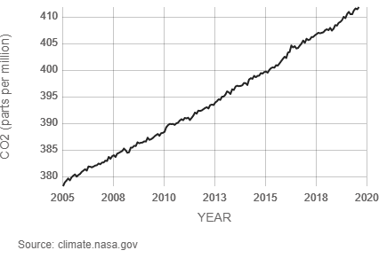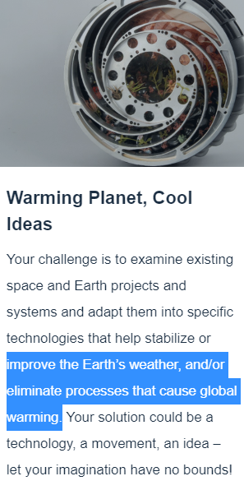

so why nasa interesting about global warming specially about co2 .Lets go and find from [NASA Climate Change](https://www.youtube.com/channel/UCP_hZt43bbGGf9ah6ATOvEg) department

(0:00 -1:00 minuit with voice)( <https://www.youtube.com/watch?v=f9F7yDjSdNA&feature=youtu.be>)

So now as we know co2 is one of the main reason for global warming so our project is to design a process that eliminate the burning of fuel that produce co2

In our solution instead of burning gas to run the boiler to make electricity in many industry we will use solar energy to run the boiler

(akhane animation hobe)

From the animation we can see a blast of sun energy came to an parabolic mirror and then focused on a single point of a boiler which convert the water into stem by which we can make electricity from a generator

In a conclusion we can say that this solution along can not replace the gas burning me method But it canj minimize the production of co2

From a rough calculation

From a parabolic mirror (16 square meter ,380 pieces of mirror ) we can obtain 550 degree Celsius where water need 100 degree Celsius to make stem

So from a solar plant having 73 parabolic mirror (16 square meter ) we can get 3.5 ton stem per day that means 1277.5 ton stem per year. Without burning a single amount of gas( sourse: Shirdi's Maha-Kitchen)

It also cam save around $ 41,032 per year